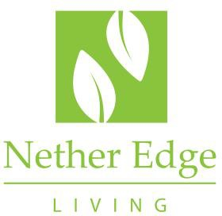

Studio Booking Form

Please read the Studio Use Policy - by signing this form you are accepting this policy.

This form should be submitted at least two weeks before the date required so that authorisation may be obtained.

**Name of Registered Resident:**

**Address:**

**Contact phone number and email:**

**Nature of Event:**

For themed or children’s parties - A £150 deposit is required to be paid to NEMC one week in advance of the event (Bank Details NEMC Account Number 13151174 Sort Code 207692)

**Event Date:**

**Time** *(to/from, including set up - please note a maximum of 2 hours is allowed in total, except for children’s parties where 4 hours is the maximum time slot allowed)***:**

**Numbers expected (minimum and maximum):**

**I confirm I have read and agree to abide by the terms and conditions outlined in the Studio Use Policy.**

**Signature: Date:**

**Please complete this form and email it to** [**estatemanager@netheredgeliving.co.uk**](mailto:estatemanager@netheredgeliving.co.uk) **or hand this form into Estates Office Reception within 2 weeks of the event date**

**Your booking is not confirmed until you have had confirmation by email.**

**For office Use (where applicable)**

**Deposit Received by on**

**Deposit Returned to bookee by on**